Create Connection from
Resource Server to Keyloak
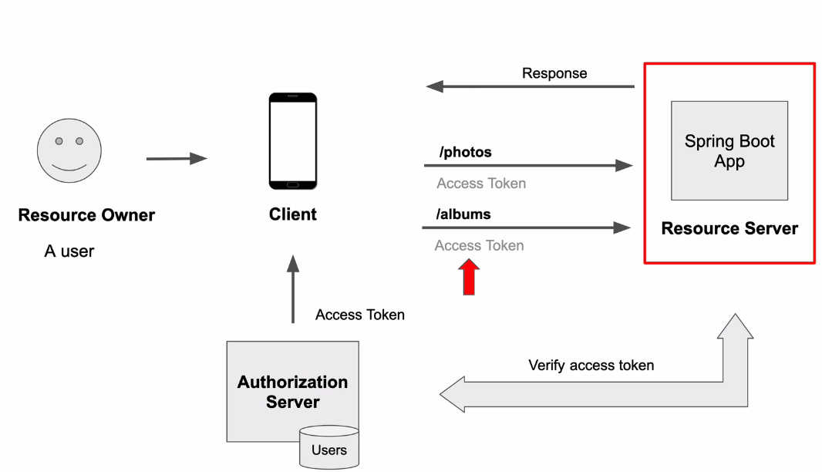

- Connection to keyloak: In the application.yml:
spring:
application:
name: ResourceServer
security:
oauth2:
resourceserver:
jwt:
jwk-set-uri: http://localhost:8080/realms/adminapps/protocol/openid-connect/certs
server:
port: 8081
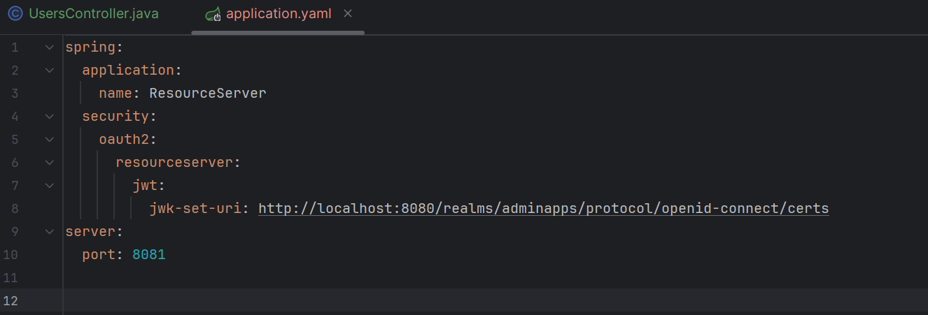

Need: Access token that come from keyloak
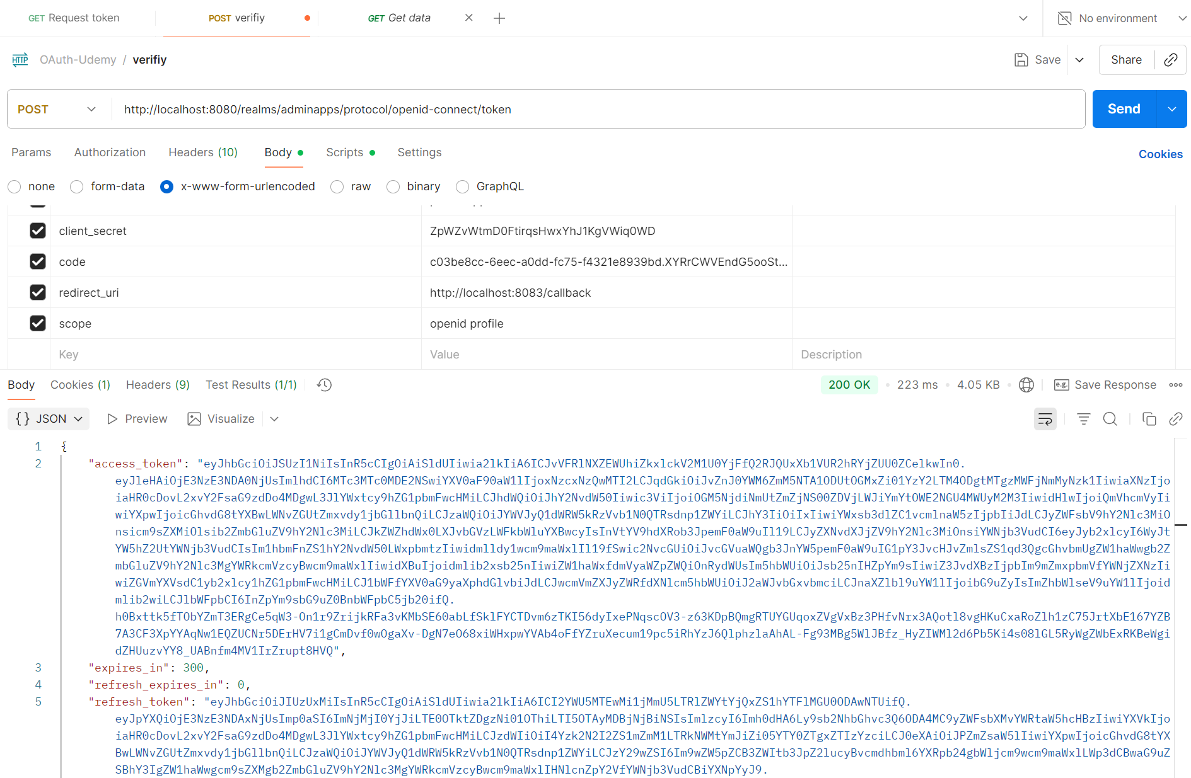

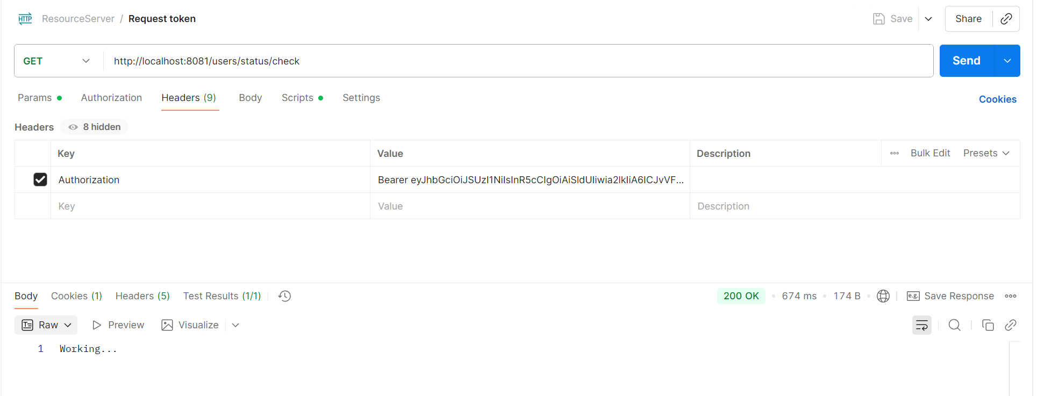

- Controller

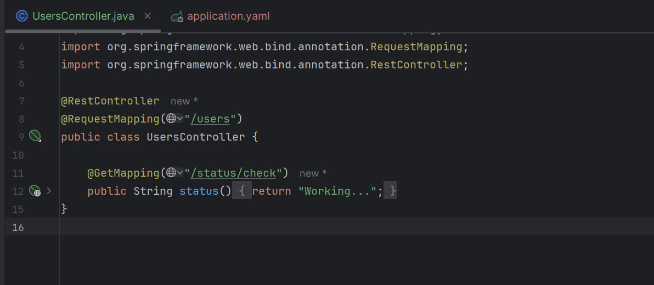

- Create Spring boot project

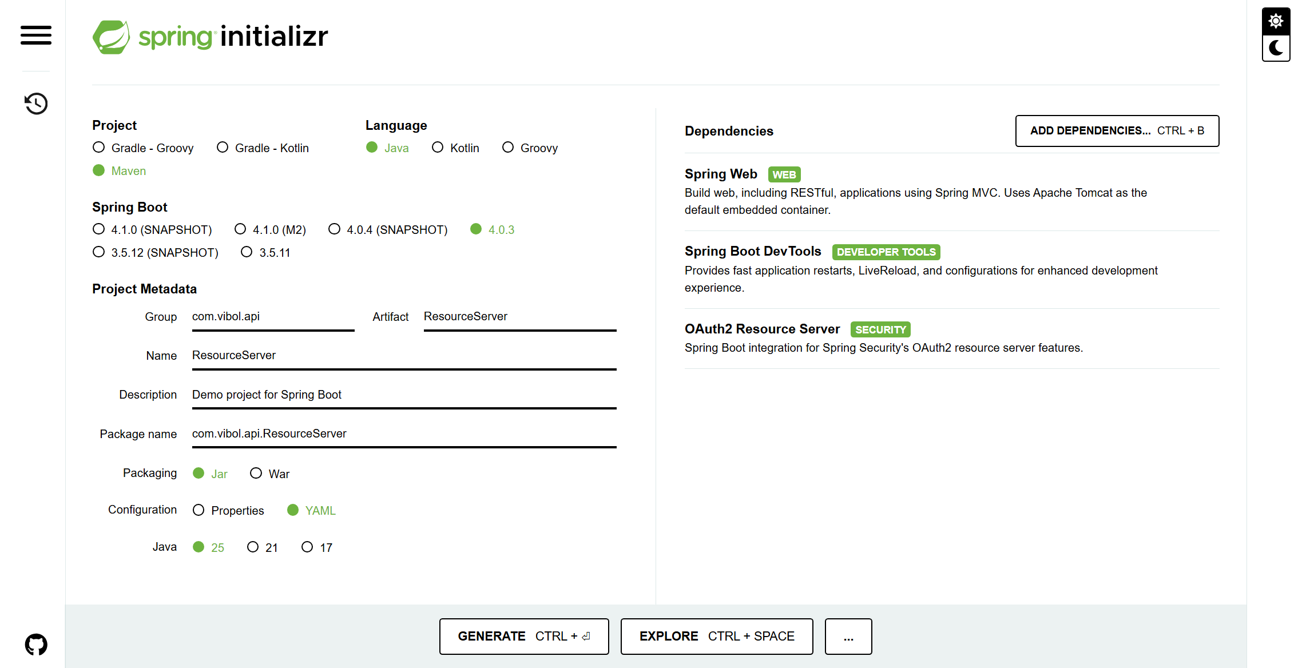

Importance: OAuth2 Resource Server

